Spearman's Correlation Coefficient (Spearman's rho) assesses the strength and direction of the association between two variables based on their ranks. Unlike Pearson’s correlation, which measures linear relationships, Spearman’s rho is used when the relationship between variables is monotonic but not necessarily linear.
To calculate Spearman’s rho, we first assign ranks to the data points for each variable. Each individual value is replaced by its position when all values are ordered from lowest to highest. Once the ranks are determined, we compute the correlation between these ranked variables. A higher absolute value of the coefficient indicates a stronger association, with a value closer to +1 meaning a perfect positive correlation, and closer to -1 indicating a perfect negative correlation.
See the following if you’d like to see a step-by-step guide to calculating Spearman’s rho manually, including all the intermediate steps.
Example Data
We have two variables, X and Y, with 6 paired observations:
X | Y
10 | 50
15 | 60
20 | 55
25 | 85
30 | 70
35 | 80

Step 1: Rank the Data
We assign ranks to both X and Y separately. If there are ties, assign the average rank.
Ranking X values
- 10 → Rank 1
- 15 → Rank 2
- 20 → Rank 3
- 25 → Rank 4
- 30 → Rank 5
- 35 → Rank 6
Ranking Y values
- 50 → Rank 1
- 55 → Rank 2
- 60 → Rank 3
- 70 → Rank 4
- 80 → Rank 5
- 85 → Rank 6
Now we add these ranks to our table:
X | Y | Rank(X) | Rank(Y)
10 | 50 | 1 | 1
15 | 60 | 2 | 3
20 | 55 | 3 | 2
25 | 85 | 4 | 6
30 | 70 | 5 | 4
35 | 80 | 6 | 5

Step 2: Compute the Differences (d) and Square Them
For each pair, compute:
di=Rank(Xi)−Rank(Yi)
Then square the differences:
Rank(X) | Rank(Y) | d=Rank(X)−Rank(Y) | d^2
1 | 1 | 0 | 0
2 | 3 | -1 | 1
3 | 2 | 1 | 1
4 | 6 | -2 | 4
5 | 4 | 1 | 1
6 | 5 | 1 | 1
Now, sum the squared differences:
∑d^2=0+1+1+4+1+1=8

Step 3: Apply Spearman’s Rank Correlation Formula
Spearman’s rank correlation coefficient formula is:
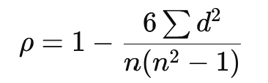
where:
- n= number of data points =6
- ∑d^2 = 8
Substituting values:
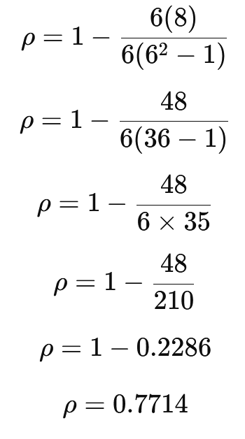

Final Answer
The Spearman’s Rank Correlation Coefficient for this data is 0.771 (rounded to three decimal places).
This suggests a strong positive correlation between X and Y.

